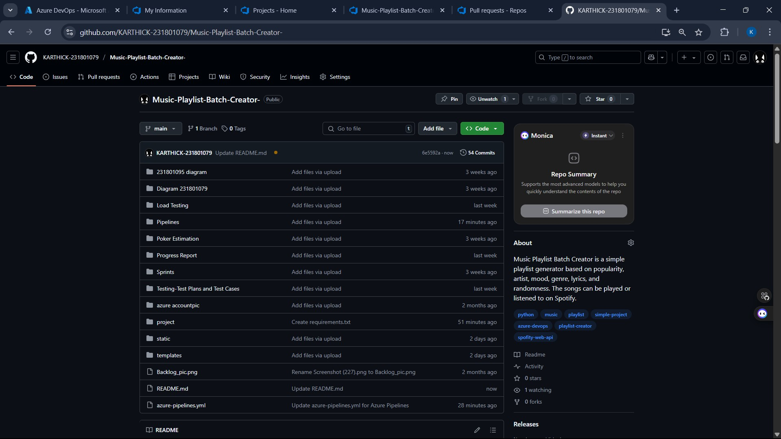

EXP NO: 10
GITHUB: PROJECT STRUCTURE & NAMING CONVENTIONS

Aim:
Create Epic, Features, User Stories, Task
To provide a clear and organized view of the project's folder structure and file naming conventions, helping contributors and users easily understand, navigate, and extend the Music Playlist Batch Creator project.

GitHub Project Structure

Result:
The GitHub repository clearly displays the organized project structure and consistent naming
conventions, making it easy for users and contributors to understand and navigate the codebase.

STUDENT REG NO CS23432

